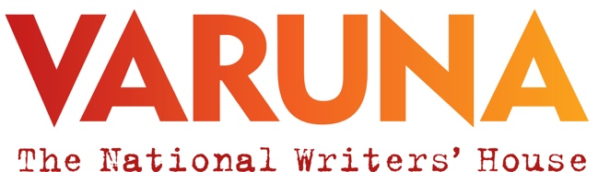

Varuna Accessibility FAQs for Writers in Residence

“Varuna will reflect the talent of all Australian writers, making our residencies and services accessible to all.”
Varuna, the National Writers’ House Strategic Plan 2021-2024

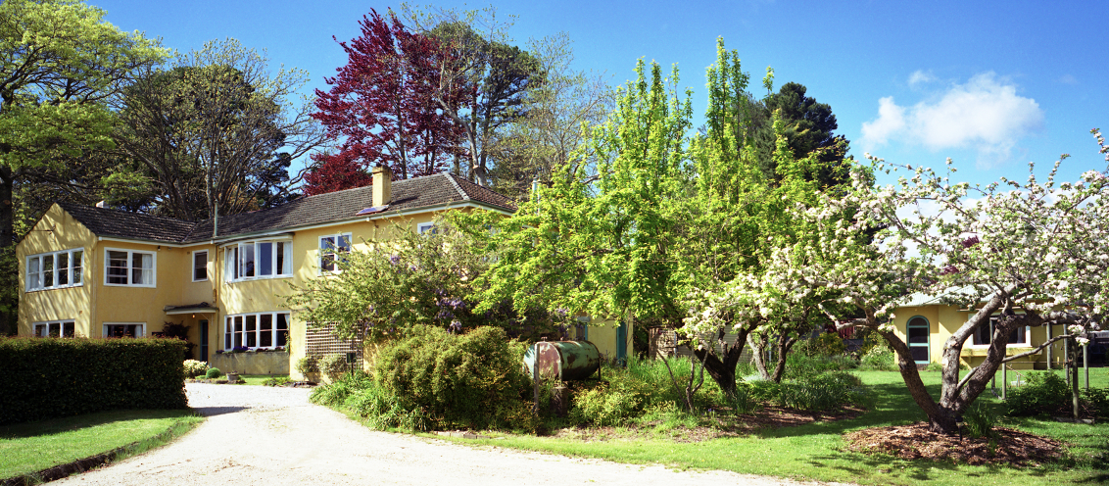

Introduction
Varuna’s vision of fostering an inclusive community for writers with disability has come a step closer with the completion of a wheelchair accessible studio on our historic premises. This new building opens up opportunities for writers with access requirements who have previously been unable to stay in residence at Varuna. This milestone is part of a broader, ongoing process of increasing access to Varuna as a place for all writers.

To assist writers with disability decide about the feasibility of staying at Varuna, the following information is offered as an initial guide. If any information is missing, if you require information in another format, or if you have any questions at all, please get in touch so we can discuss the options.

Information for those considering applying to stay at Varuna, the National Writers’ House

How do I get to Varuna?
Varuna is located at 141 Cascade St, Katoomba. Please note that Varuna is a residential writers’ retreat, and is generally not open to the public, but we can arrange an appointment for you to view the facilities in advance of your stay if you would like to do so.

For directions to Varuna via train, car or on foot, please click here for downloadable version. Or go to https://www.varuna.com.au/directions. Please note Katoomba station has a lift to street level and the taxi rank is just outside the station on the town side.

Blue Mountains Maxi Taxi- can be contacted on 0423 890 670 or through their website https://blue-mountains-maxi-taxi.business.site/ and can transport you from Katoomba station to Varuna and for other local incidental travel.

Australia Wide Coaches offer a coach service from Sydney Domestic Airport and Sydney Central to Katoomba on the Sydney to Orange route. For further information go to: https://austwidecoaches.com.au/timetable/

Unfortunately there are no local buses that stop in the vicinity of Varuna.

Is there staff on site at Varuna?
All Varuna’s staff work part-time and there is no resident groundskeeper. Staff are in the onsite office (the shed!) Monday-Friday during office hours and will be there to greet arriving residents every Monday. No staff are onsite on the weekends. Contact numbers are provided for after-hours emergency situations.

Employees have undertaken disability awareness training and can be contacted in advance to prearrange assistance for residents with disability.

What areas of Varuna are wheelchair accessible?

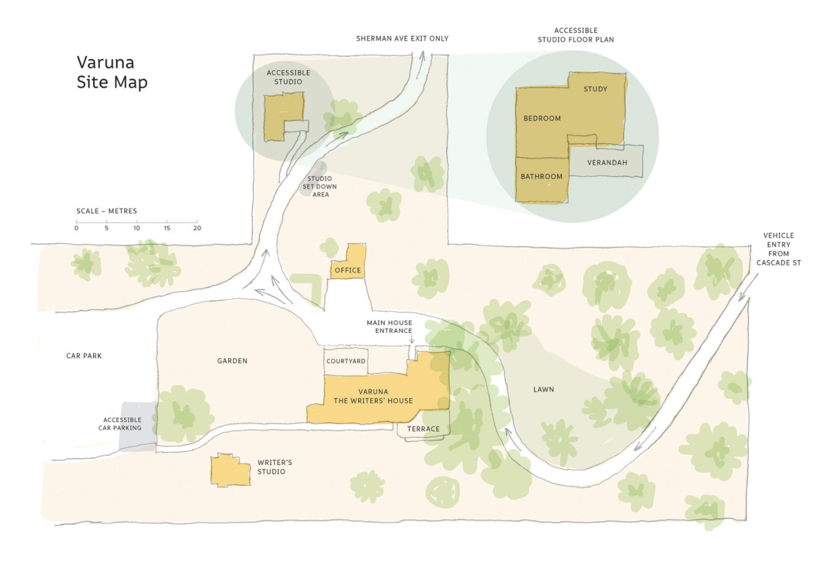

Wheelchair access to the main Varuna house is via the front door entrance when the temporary ramp is fitted. There is a level, compacted gravel path from the driveway to the main entrance.

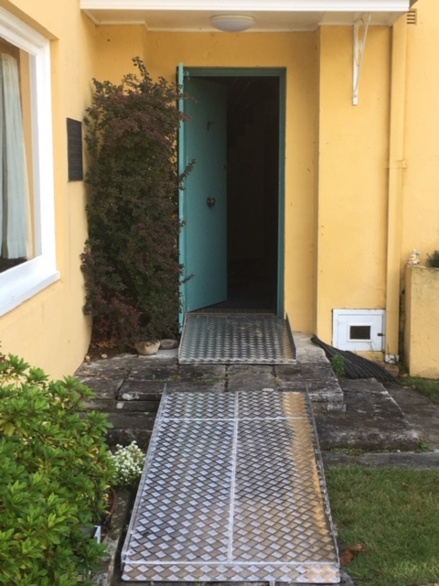
Entrance to main house with ramp in place

Upon entering the main house via the front door, all downstairs areas of the house are on one level including the lounge and library, dining room and kitchen. Please note the downstairs toilet has not been able to be modified to enable full wheelchair access. However, writers who use a lightweight wheelchair, crutches or a walking frame may find the space accessible depending on their access requirements. There is no wheelchair access to the upper level of the house.

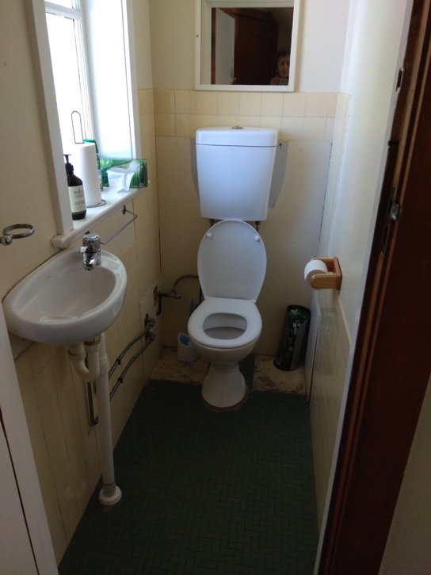
Downstairs bathroom

The wheelchair-accessible parking space is located in the Varuna car park and there is a level, compacted gravel pathway to the new Varuna Studio. Please note residents can temporarily park close to the new Studio to unload the car and then park in the car park for the duration of the residency.

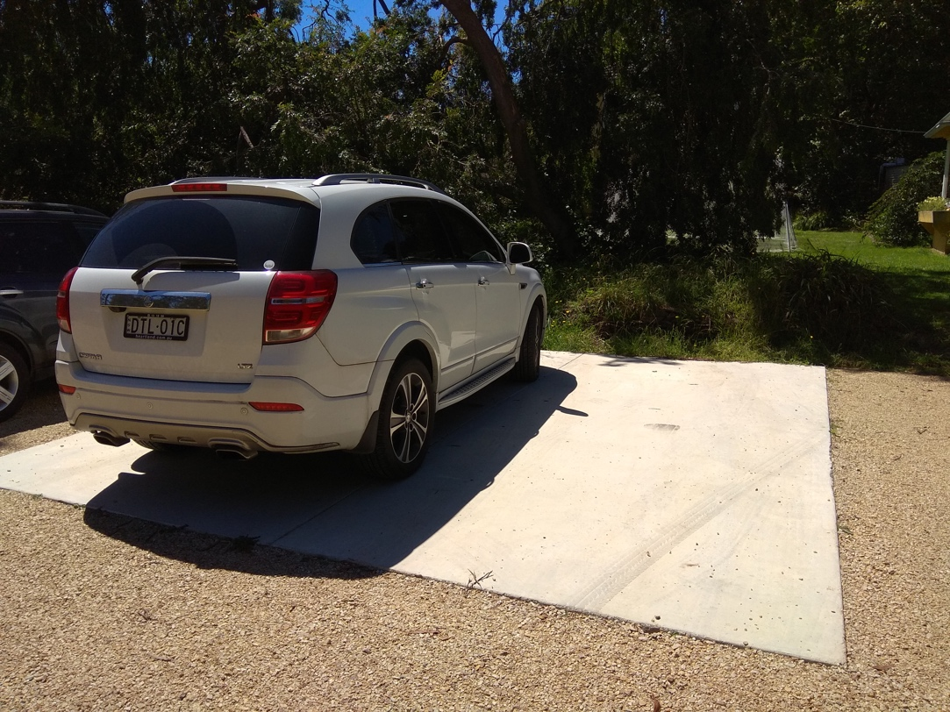
Wheelchair-accessible parking space

All ramps have building standard grading and landings.

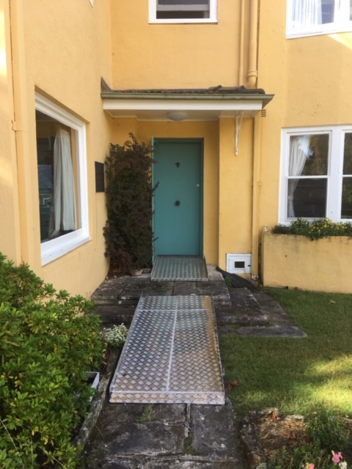

All doors are manual, are at least 850 mm wide, and have space to enable a person using a wheelchair to enter/exit and manoeuvre.

Please note manual doors are not currently weighted. Door handles are at a height that is within reach of people using a wheelchair, and are of universal design. When the front door to the main house is closed, unlocking it currently requires inserting and turning a key in a security lock.

Floor surfaces in the downstairs section of the main house are carpeted. The new studio has timber flooring with a rug that can be removed.

The new Jerra Studio
The new Varuna Studio is fully accessible and includes an accessible bathroom, which complies with Australian Building standards. The grab rail is positioned on the right side of the toilet in the bathroom.

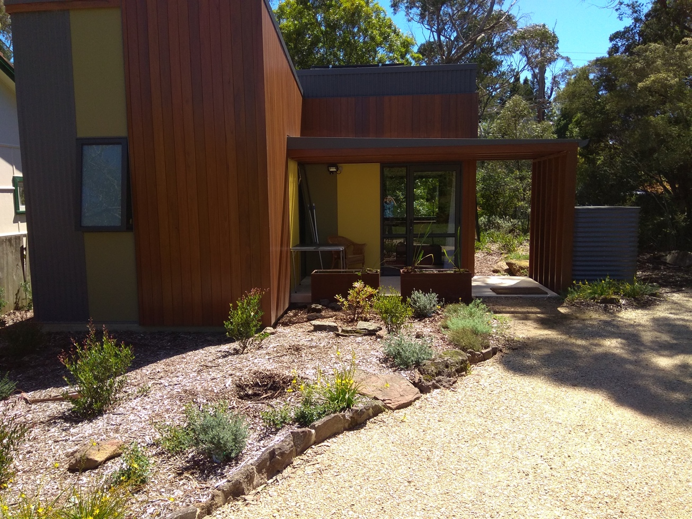
New wheelchair accessible studio
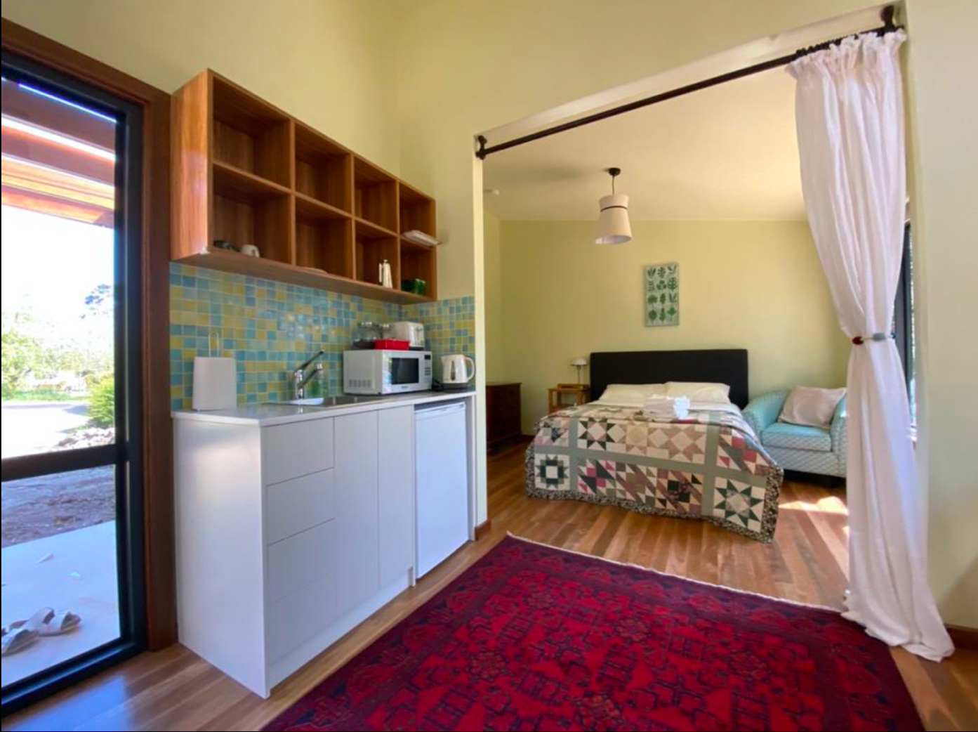
New studio interior and kitchenette

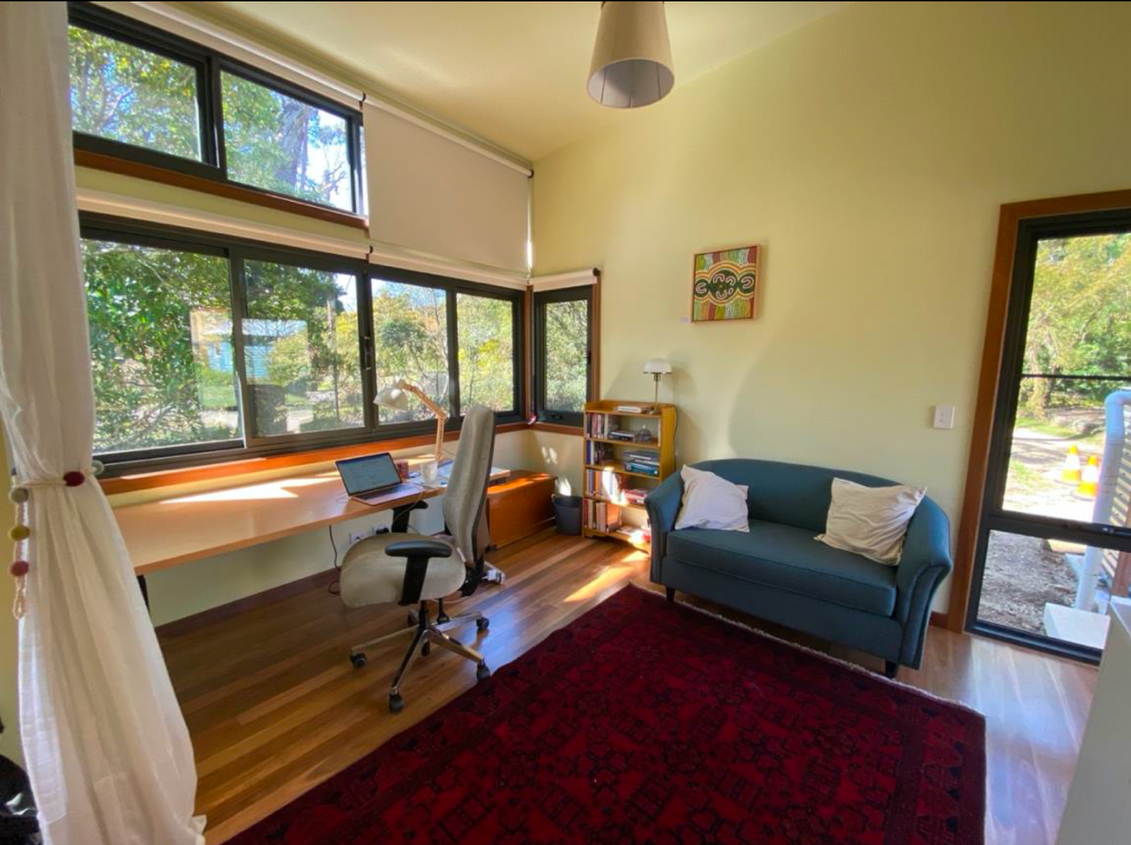
Working space in the new studio
The new studio also features:
- Desk: Ascend Electric Adjustable Table. Height range 620mm Min 1270mm Max
- Chair: Ergopedic Controller High Back Chair Arms. Extra High Back. 2XL Seat 560mm W x 510mm Moulded foam throughout with Visco Foam overlay Adjustable T Style arms, 3 Lever ergonomic action. Adjustable Height back support - Ratchet.
- AH Beard Enliven Adjustable Base double bed - height of the bed from the ground: 65cm
Firmness of bed: firm. Electric blanket
- Touch lamp on the bedside table
- Kitchenette doors and drawers are ‘push to open’. Please note the kitchenette is at a fixed height.
- Air conditioning

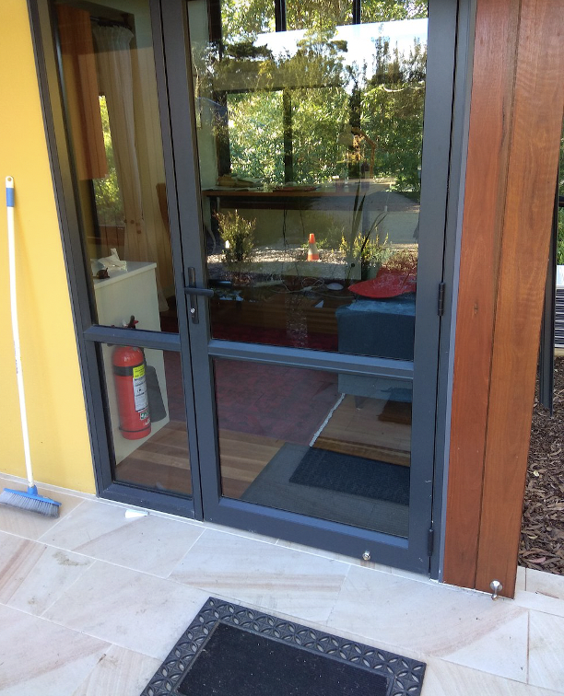 Front door detail
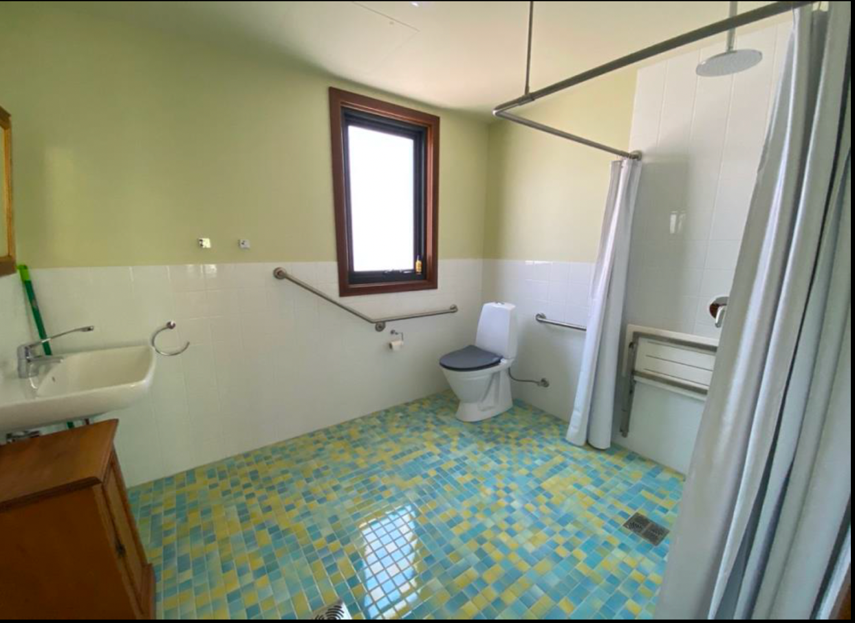

Bathroom in the new studio

Shower showing bench (when it’s down) The height of the shower bench from ground: 48cm

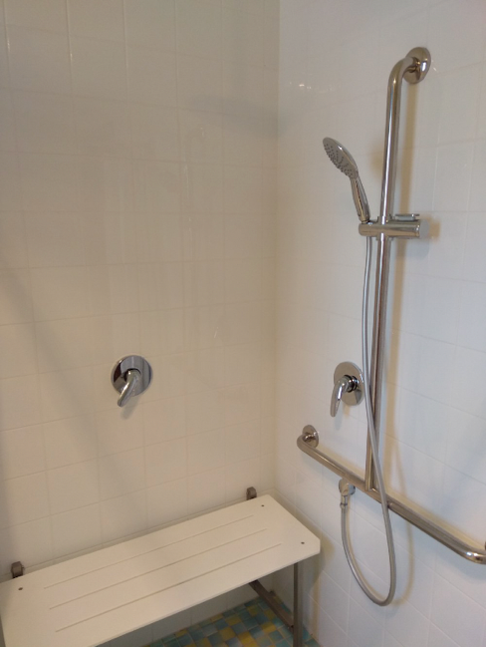
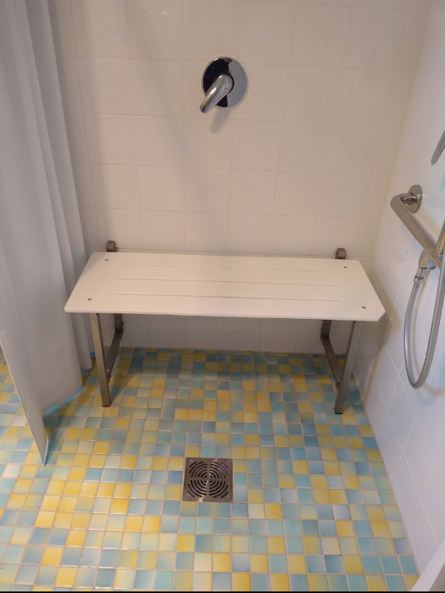

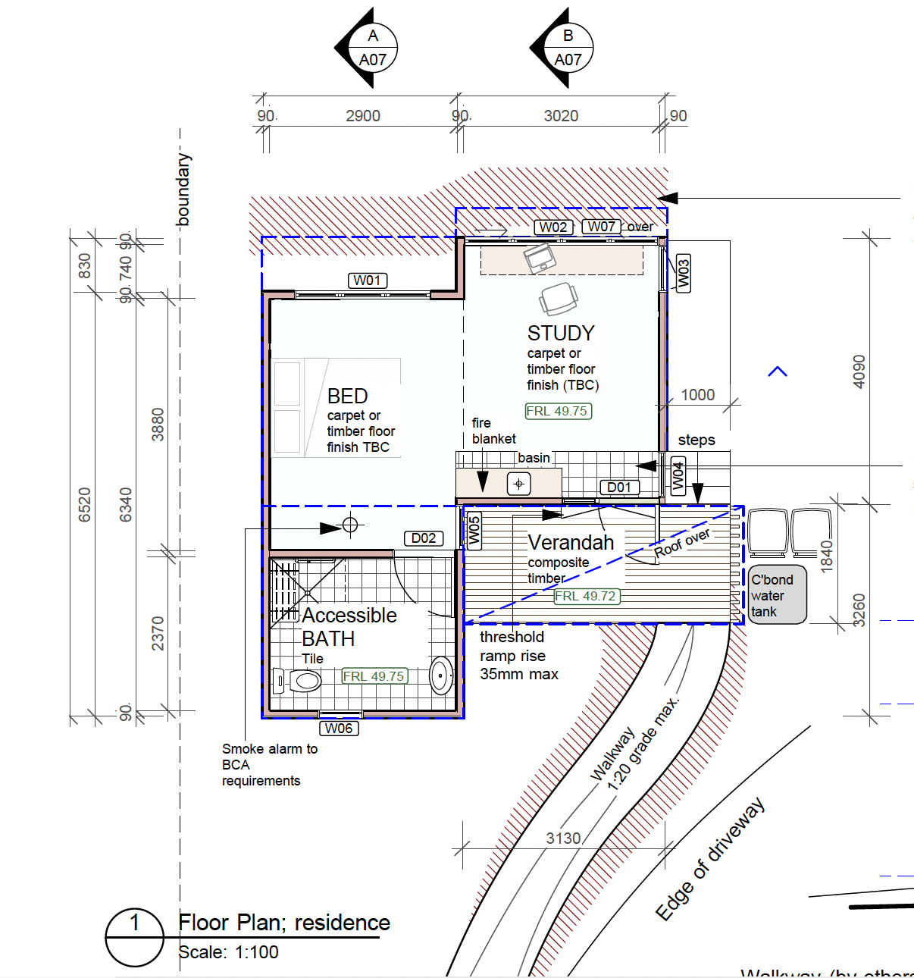
Floor plan with dimensions

What is the condition of the stairs to the upper level of the house?
Stairs comply with building standards for height and consistency. The stairs have a handrail and are carpeted.

What are noise levels like at Varuna?
Unless you’re on a specific residency program which includes workshops and group sessions, all residents and staff observe quiet time between 9 am and 6 pm. Residents are asked to avoid reading out loud if in one of the upstairs bedrooms and asked not to disturb other writers.

The Eleanor Dark studio and the new studio are both separate from the main house and can be used by writers who need to speak out loud for their process. Mobile phones are switched off or to silent during the day and residents are asked to be at a distance from the house before making phone calls (the area in front of the house is sensitive to noise travelling to the upstairs rooms).

Is there a hearing augmentation system?
There is no inbuilt amplification system at Varuna currently available therefore there is no hearing augmentation system.

Are there Tactile Ground Surface Indicators in use?
Currently we do not have hazard marking Tactile Ground Surface Indicators. We have ensured that people who are blind or have low vision have been able to stay at the house through other types of support including assistance animals. If you would like to discuss this further please call.

Are assistance animals catered for?
Assistance animals are welcome at the Varuna house and there is an area for assistance animals to be toileted.

What mental health associated supports are available during my stay if needed?
Varuna’s Residency Handbook is provided to all residents upon arrival and includes the contact details of mental health support services available in the local area.

Are emergency exits marked? Are evacuation procedures in place for people who may require assistance?
Emergency exits are clearly marked and accessible for a person using a wheelchair (NB the temporary ramp to the main house remains in place for the duration of the residency). There is a level, compacted gravel path from exits to the designated safe area via the driveway. Luminous indicators are not used in the house. Smoke alarms are fitted in the case of an emergency. Currently there are no visual warning signals in the event of an emergency so alternative arrangements are made if required.

What happens when there is a bushfire?
If an emergency occurs during a day when Varuna staff are at the house, staff will liaise with residents in the first instance. If bushfire threatens an area in the vicinity of Varuna, you may be asked by emergency services personnel or Varuna staff to leave. If you require particular assistance with enabling this, please let us know prior to your stay and we can assist with supporting you with the necessary arrangements. Emergency numbers are also provided in the residents’ handbook.

In the event of a bushfire, Varuna’s evacuation point is the Carrington Hotel, which is located a few minutes away by car in the main street of Katoomba. If possible, staff will arrange transport to the hotel or you may use your own vehicle if travelling by car. It is not intended that you stay at the Carrington but we have chosen this as a venue which is close by, is located in a built-up area, and which has some facilities, including a wheelchair accessible bathroom, if it is necessary to stay for an hour or two.

Is there lighting between the house and the new studio?
Outdoor sensor lights are in operation at the Varuna house main entrance and the entrance to the new studio. The pathway between these two places is not currently specifically lit.

Can a support worker stay with me during my residency?
If you notify us in advance of your residency that you would like a support worker to stay with you, we can make arrangements for them to either stay at the house or in a nearby holiday house. If you receive NDIS funding, we can provide any information required to ensure your NDIS support can be used to assist your stay.

Can you recommend local services?
Varuna staff will endeavour to find recommended local providers of any service you might require during your stay e.g. acupuncture, physiotherapy, local support workers, etc .

What happens if I become unwell while I am at the residence?
If you become unwell while at the residence, so much so that it effects your ability to carry out your work, we encourage you to seek medical support and possibly return home. A full refund will be offered in these circumstances so you have the ability to return when you are feeling better.

Do I let other residents know about my disability?
The Varuna residency is a unique creative experience and the peer relationships developed during your stay thrive on honest and open communication based on respect and trust. We encourage all residents to uphold these values and in doing so make sure everyone feels safe, included and supported. Part of our Disability Inclusion Action Plan is to play a role in raising awareness about social barriers to writing practice.

If there is any aspect of your disability you wish to disclose to your fellow residents before you all arrive for your residency, please let us know. (For example, if you have an assistance animal it may be worthwhile for us to let fellow residents know that the animal is not be patted unless you indicate it is ok to do so).

Upon your arrival at the House
A staff member will be there to greet you upon arrival. You will be given a guided tour of the facilities and you have the chance to ask any questions that may arise about staying at Varuna. There will also be a resident’s handbook in your room which outlines everything you need to know including emergency procedures and phone numbers. If you would like a copy of this document before your stay please let us know.

On the afternoon of your arrival a ‘meet and greet’ takes place in the lounge room with all residents and a Varuna staff member. You will be given an overview of the history of Varuna and provided with a chance to meet your fellow residents and discuss the writing projects you will be working on during your stay.

We encourage each cohort to plan a 30-minute reading and feedback session for each resident writer during the week. These usually take place on the Wednesday and Thursday afternoon. We encourage writers to share work via email in advance of the session and then keep to 10 mins of reading and 20 mins of discussion, with two or three sessions running back to back each afternoon.

During your stay at Varuna
If there is any additional support you require during your stay, please don’t hesitate to let staff know. i.e., assistance using the washing machine, food served directly, a companion for a local walk. We can either arrange to have staff available or organise additional local support workers to assist you.

If there is any aspect of your residency that might make you or others feel unsafe please raise this asap with Varuna staff.

We are all learning
Creating a welcoming and accessible writing space that recognises and supports people’s needs is a work in progress at Varuna. We are committed to asking for ongoing feedback from everyone who stays at our historic property or attends our virtual or live events. If you think of anything that could be improved, please let us know. Please contact Rebecca Goosen, Strategic Initiatives and Development Officer, rebecca@varuna.com.au or phone 02 4782 5674.

